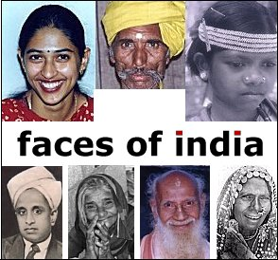

INTRODUCTION
India is one of the most richly colourful and enjoyable places to travel. It is a place where the past and present live together, presenting the visitor with a wealth of impressions; the architectural glories of myriad ancient civilizations; fantastic art and complex religions; places of astonishing natural beauty; and the sight of India’s people going about their lives in ways that often stem directly from the past.

Most of all, India is wonderful to visit. As a modern-day traveller, you cannot fail to be touched by the warmth and welcome you receive in cities and villages alike. Each day offers a fresh adventure. One day you will ride a painted elephant to see the elaborate fort built by Rajasthan’ s rulers of the 17th century and on another day, you will visit the fabled Taj Mahal, an enduring monument to love and perhaps the most perfect example of grace and symmetry ever created. In the great cities of Bombay and Delhi, you see the legacy of past rulers and gain valuable insight into today s urban India.
India as it is often said is not a country but a continent. From north to south, east to west, the people, their languages and their customs are different. It can be said, that there are few countries on Earth with the enormous variety that India offers. Love it or hate it, you can never ignore India. There are visitors who have left the country with a sigh of relief, but are waiting to get back after a year. To further enrich your visit, there are many opportunities to meet and talk with people you encounter along the way.
Our suggested program given below ensures safety, offers comfort, provides opportunity for social inter-action, time for shopping and at the same time keeps the educational content in mind.
We hope you will join us on this exciting regal tour of India…..

Delhi * Agra * Jaipur * Bombay

25th AUG (Friday): DELHI – ARRIVE AT 2030 HRS BY AA-292

Arrive this EARLY morning from Toronto by AI flight. After clearing immigration and custom formalities, you will be required to collect your bags from the baggage belt and proceed to the arrival lounge. A representative will be waiting there and will transfer you to your Hotel.

Overnight at hotel.

26th AUG (Saturday): IN DELHI

Morning buffet breakfast at the hotel, and then you will proceed for a full day city tour of Old & New Delhi.
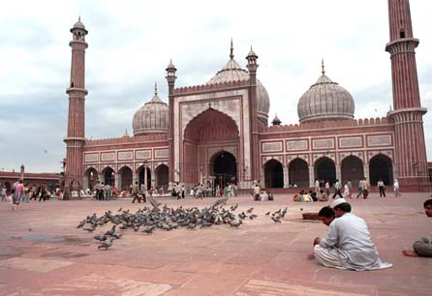
You will first visit Old Delhi. The tour will begin with a visit to Raj Ghat, a simple memorial to Mahatma Gandhi; drive past the Red Fort continuing to the Jama Masjid by bicycle rickshaws, one of Asia’s largest mosques. The magnificent Red Fort, overlooking the river Jamuna was built during the years 1638 - 48 when the Moghul Empire was at its peak. The tour continues to Jama Masjid, one of Asia’s largest mosques and which is viewed from the outside. People stream in and out of the mosque continuously and the presence of a nearby bazaar means that the area is rarely quiet.

After visiting Old Delhi, you will be driven to New Delhi, which reflects the legacy the British left behind. The division between New and Old Delhi is the division between the capitals of the British and the Mughals respectively. The division in the walled city and New Delhi also marks the division in the life-styles. The walled city is all tradition where one will be able to glean a past life-style in all its facets, colours and spells. New Delhi in contrast, is a city trying to live up to the best of 21st century standards.
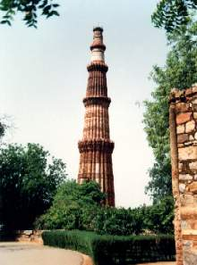
The tour to Imperial Delhi will include a visit to the Qutub Minar, the tallest stone tower in India. Qutub-ud-din Aibak started it in 1199. Pulling down 27 Hindu and Jain temples and using their columns erected the attached Quwwat-ul-Islam mosque also built by him. Then visit Humayun’s Tomb, built by the widow of the second Mughal Emperor, Humayun, it is an outstanding monument in the Indo-Persian style, a precursor of the Taj Mahal. The tour also includes a drive past the imposing India Gate, the Parliament building and the Rastrapathi Bhawan, the President’s residence.

Return to your hotel after the sightseeing tour.

Overnight at the hotel

27th AUG (Sunday) : DELHI-AGRA

Breakfast at the hotel.

In time drive to Agra (205 Kms/ 4 hours). Upon arrival check-in at the hotel.

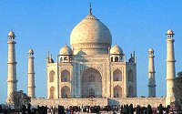
Although Agra is an ancient city in India’s heartland, it came into prominence in medieval times when the lavish patronage of the Mughal rulers created forts, tombs, and palaces in red sandstone and marble, inlaid with semi-precious stones. This morning you will visit the massive Agra Fort, where the ageing Emperor Shah Jahan, imprisoned by his son, watched from a distance the fulfilment of his life’s dream-the building of the Taj Mahal in memory of his beloved wife.

Afternoon, sight-seeing of this city, visiting the impressive Agra Fort with its various palaces including the palace where the aging Emperor Shah Jahan, imprisoned by his son, watched from a distance the fulfillment of his life’s dream – the building of the Taj Mahal, in memory of his beloved wife. Later proceed to the Taj Mahal to gain a sunset, perspective of the site, the highpoint of the day, incredibly perfect in its symmetry. On the inner walls jewel like stones create beautiful designs in white marble. The Mughals perfected the art of embedding semi-precious stones into marble and the Taj is the finest example of this, it is a special process called pietra dura. Enjoy the tonga cart ride from Taj Parking till Taj entrance.

Overnight at the hotel.

28th AUG (Monday) : AGRA- JAIPUR

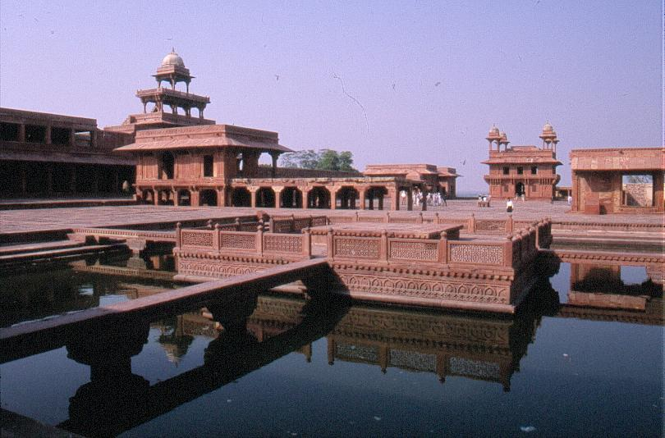
After buffet breakfast at the hotel, you will be driven from Agra to Ranthambore (260 KMS / 7 hours). En-route visiting Fatehpur Sikri, the deserted red sandstone city, built by the Great Mughal Emperor Akbar as his capital and palace in the late 16th century. It was abandoned soon after it was built when the local wells went dry and it remains today in much the same condition that it was over 300 years ago. It is complete with palaces and mosques and used to be a town larger than London when it was originally constructed. Now it is an extraordinary place to wander around with its buildings in near perfect condition.

Continue drive to Jaipur.

Jaipur, The colourful capital of a richly colourful state, is a highly distinctive planned city, made all the more attractive by the pink wash that most buildings are periodically given. It has some fine museums in the atmospheric Old City with its bazaars, palaces and havelis. Jaipur (City of Victory) was founded in 1727 by Maharajah Jai Singh II, a Kachhwaha Rajput, who ruled from 1699-1744. He had inherited a kingdom under threat not only from the last great Mughal Emperor Aurangazeb but also from the Maratha armies of Gujarat and Maharashtra. Jaipur is very much a product of his intellect and talent.

Upon arrival, proceed for check-in at the hotel.

Overnight at the hotel.

29st AUG (Tuesday) : JAIPUR

After buffet breakfast at the hotel, you will be driven just outside Jaipur to the ancient capital of Amber to see the fabulous Amber Fort. Maharaja Mansingh, Mughal Emperor Akbar’s most successful General, started the construction of Amber Fort in the 17th century.
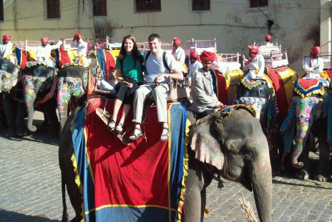
Before the City Palace was constructed in Jaipur, Amber was the seat of power. The fort is surrounded by fortified battlements and overlooks the Moat Lake. Ruins and remains are spread over the Aravalli hills and sprawling crenulated walls lattice the surrounding area.

An elephant/Jeep will spare you the trouble of reaching up to the fortress. Once on top, stroll through the sprawling complex of courtyards and halls. Many of the rooms have delightful wall paintings, with precious stones and mirrors inlaid in the walls. Most fascinating, perhaps, is the Sheesh Mahal (hall of mirrors) where a single lamplight is reflected in the many mirrors, lighting up the room.

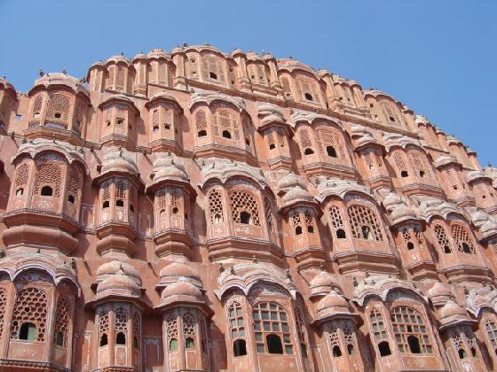
En-route to Amber you will stop and see the `Palace of Winds’, otherwise known as Hawa Mahal. It is really an elaborate facade behind which the ladies of the court used to watch the daily goings on in the street below. It is extremely intricate in its pink sandstone carving. The cool wind blows through its facade of windows and latticed screens through which the queens of the court once viewed the streets of the city.

In the afternoon, you will visit the city of Jaipur. Among the highlights to be seen while touring Jaipur include the City Palace, which is an overwhelming complex of exquisite palaces, gardens and courtyards, decorative art and carved doorways. The palace museum houses collections of rare manuscripts, armoury, costumes, carpets and miniature paintings. Walk to the adjacent Jantar Mantar or Astronomical Observatory made by the Maharaja of Jaipur, built in 1726 and is one of the five such astronomical wonders built by Sawai Jai Singh and makes accurate predictions even to this day. You will also have the opportunity to wander about the local markets. Return to your hotel after the sightseeing tour of Jaipur City.

Return to your hotel after the sightseeing tour.

Overnight at the hotel.

30th Aug (Wednesday): JAIPUR- BOMBAY

In the morning you will be met by a our representative who will transfer you to the airport to board flight for Mumbai.

Departure: Jaipur at: 0730 Hours By: IC 612
Arrival: Mumbai at: 0905 Hours

On arrival Bombay a SITA representative will be waiting there and will transfer you to your Hotel.

Maharashtra’s capital, Mumbai, wears several hats or should we say crowns? Mumbai is not just India’s largest city, it is also its commercial capital, industrial powerhouse, busiest port, fashion capital, home to ‘Bollywood’ (India’s Hollywood), world’s biggest textile market – the list goes on and on. Mumbai thrives on contrasts- the city is home to the richest and the poorest of Indians, sleek limousines jostle rusty cycles, red double-decker buses rumble past three-wheeler auto-rickshaws; impressive high rises soar above crowded ugly slums and shanty towns; glitzy shop fronts amid pavement stalls; glamorous film stars and homeless beggars demand attention at traffic lights and amidst all this are people, people, people everywhere, for Mumbai is home to some 13 million Indians.
Afternoon you will proceed to the Gateway of India to board the motor launch, which will take you to the famous Elephanta Caves (closed on Mondays).

The beautifully sculpted rock-cut temples on Elephant Island are 9 nautical miles from Bombay and are reached by taking a motor launch from Gateway of India. They are believed to have been created between 450 and 750 AD, when the island was known as Gharapuri, the Fortress City. The Portuguese renamed it Elephanta because of a large stone Elephant near the shore. The caves are reached by climbing 100 steps to the top of the hill. After the tour come back to hotel.
Overnight at hotel.

31st AUG (Thursday): MUMBAI
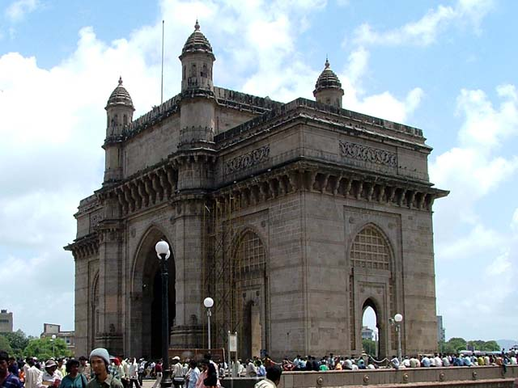
Buffet breakfast at the hotel, you will proceed for panoramic tour of Mumbai visit Gateway of India. Gateway of India is the landmark of Bombay, which, was before the advent of air travel, the only gateway to India. It was built to commemorate the visit of King George and Queen Mary to India in 1911. You will be then driven along Marine Drive, the sea - Front Boulevard. It is also known as the Queen’s Necklace as in the evening, the breeze from the Arabian Sea comes over Marine Drive and as the streetlights on this U-shaped road light up, the view from south Bombay’s skyscrapers or from the exclusive residential area, is that of a Queen’s Necklace. Your first stop will be the Jain Temples, built of marble and dedicated to the first Jain Tirthankara. From the temples you will be driven along Malabar Hill via the Tower of Silence - a round stone construction on which Parsis place their dead to be eaten by the vultures and Hanging Gardens which is built over Bombay’s reservoir. From here one can get a panoramic view of picturesque Marine Drive. Afternoon at leisure.

Overnight hotel.

01 SEP (Friday): DEPARTURE BOMBAY

After breakfast at hotel, day at leisure till departure. On time transfer to the port for boarding the ship Pacific Princess. BOARDING BEGINS AT 1.00 PM

********** END OF TOUR **********

